1. **WORK ON GIT TO GITHUB PUSH,PULL**

First we login in git-hub account and create a repository in that account.

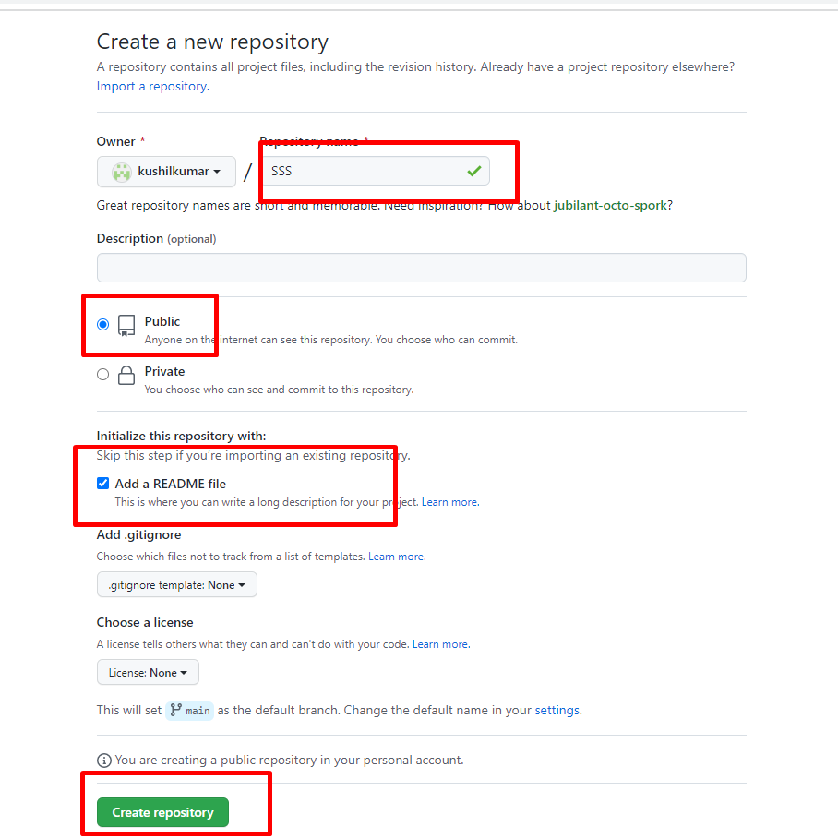

Successfully created SSS repository .

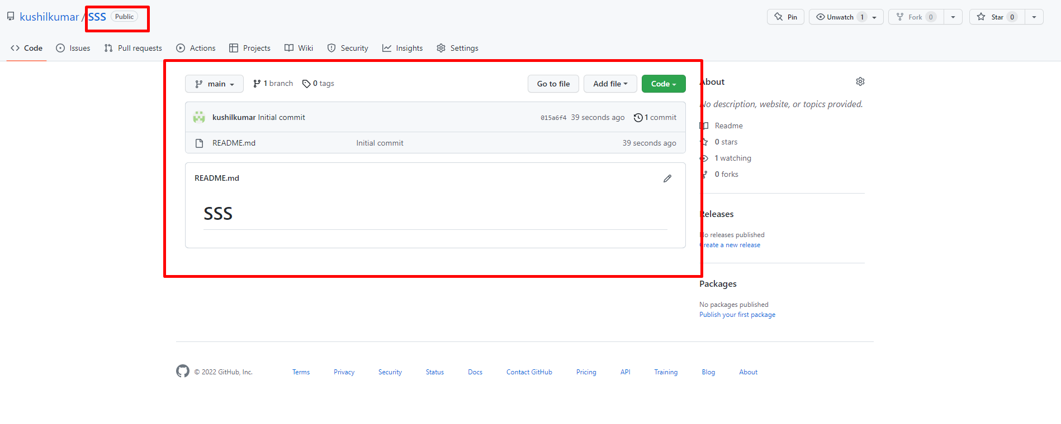

Next we install git tool in google and we open git.

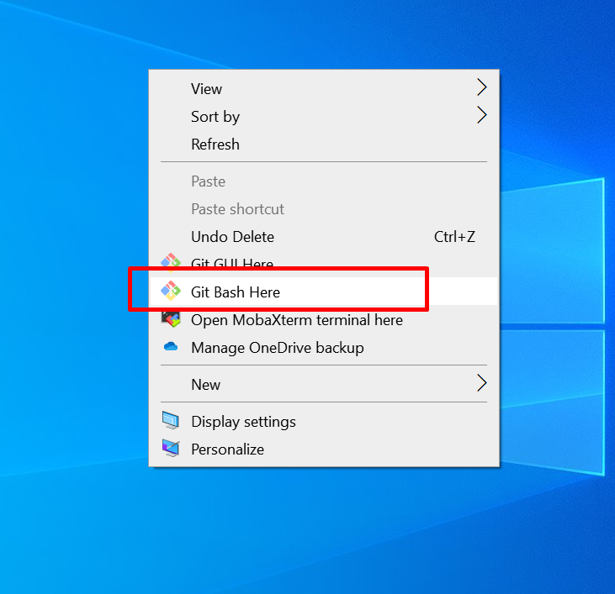

After we open git and we push TEST2 file into git-hub.

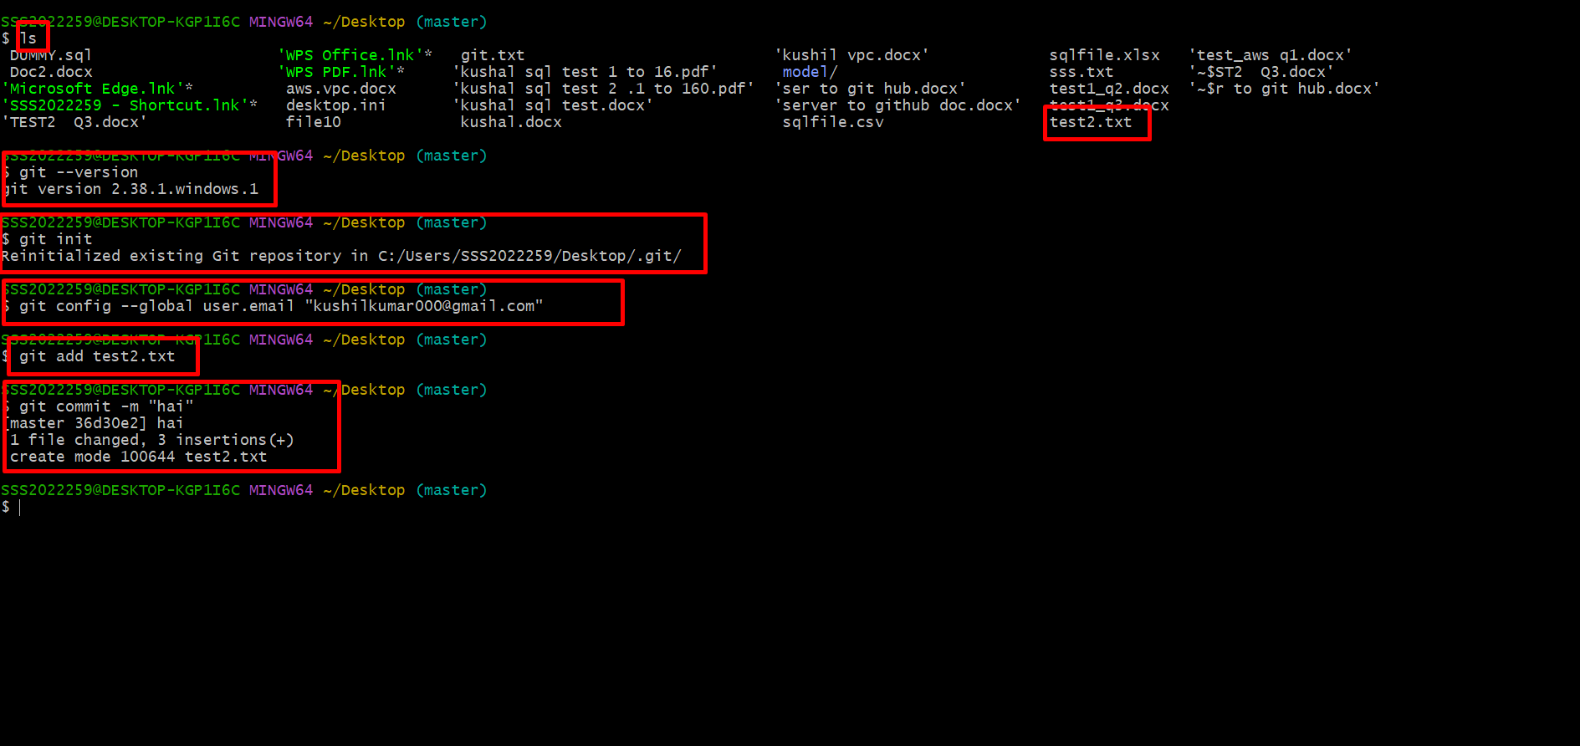

Open git-hub and we select needed repository and copy that code.

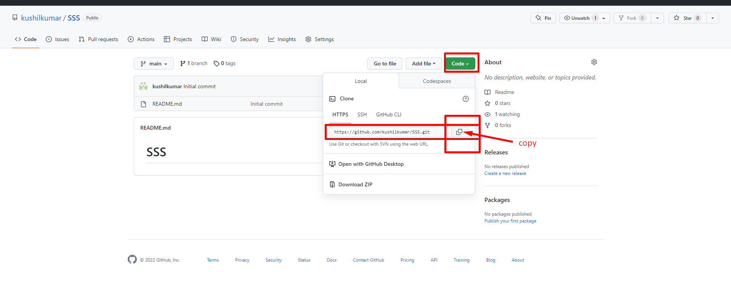

Next we go to git and paste here.

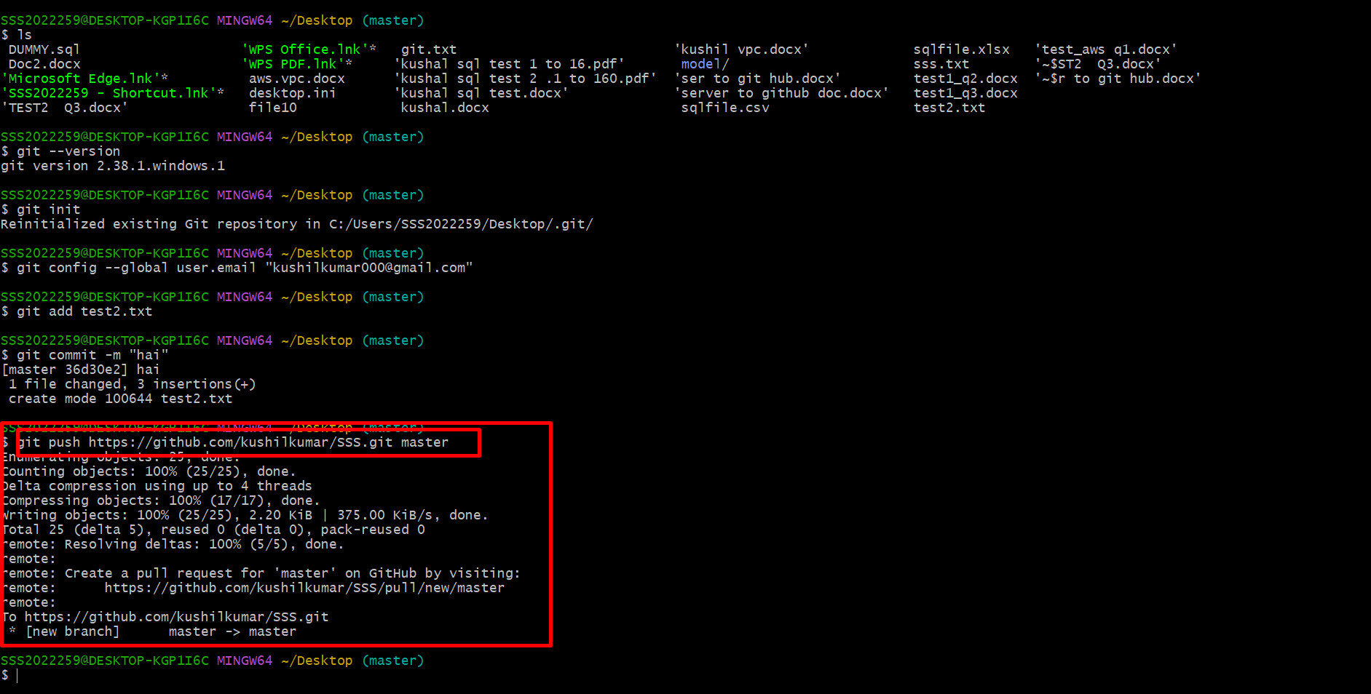

Successfully push file in git-hub.

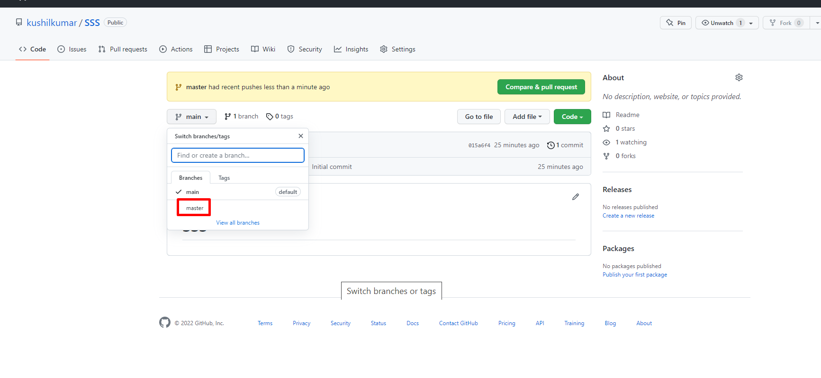

Next we open git -hub and we show our new push file in this repository

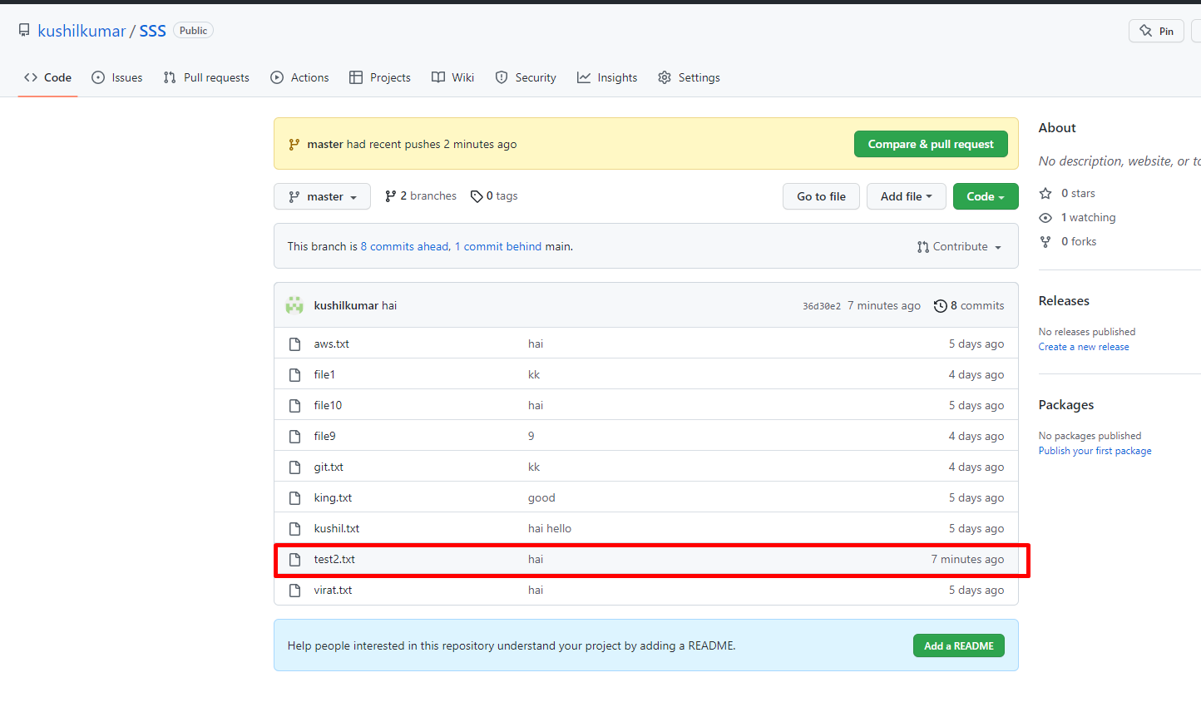

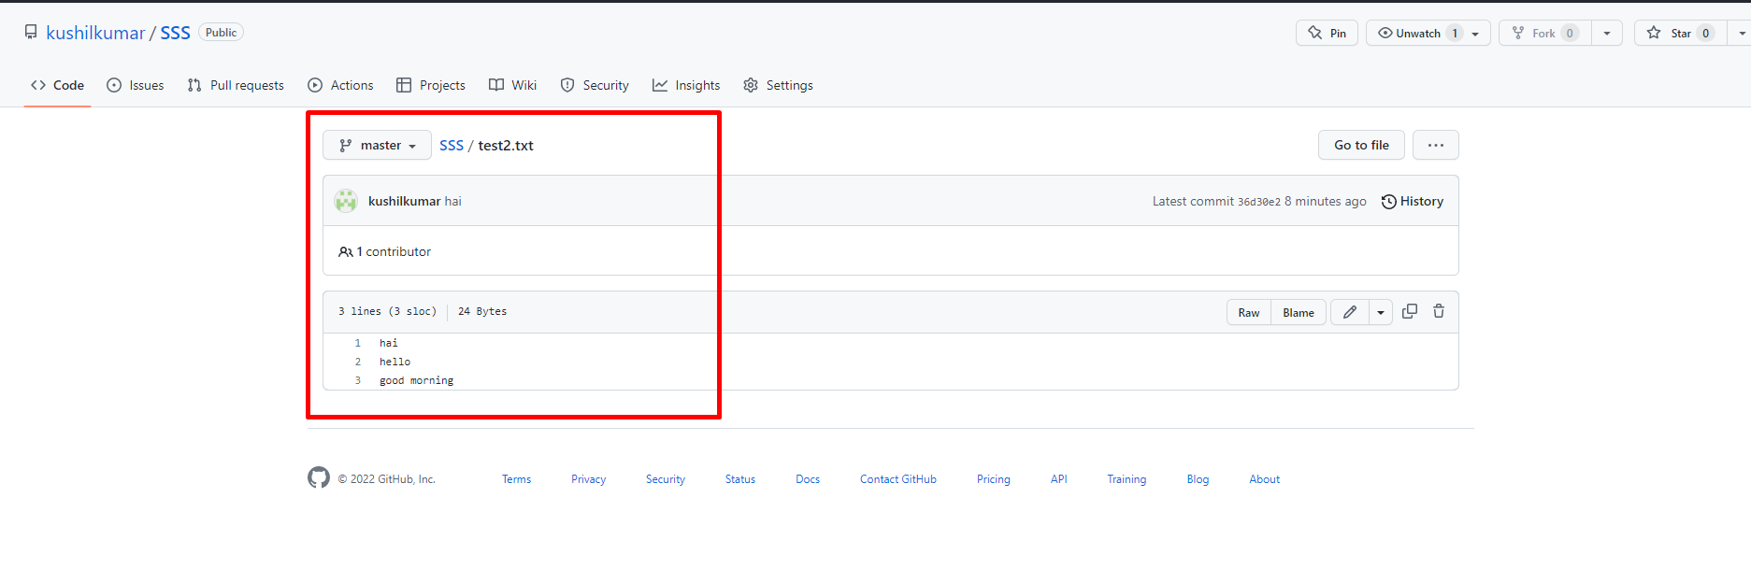

Next we pull file in git-hub.

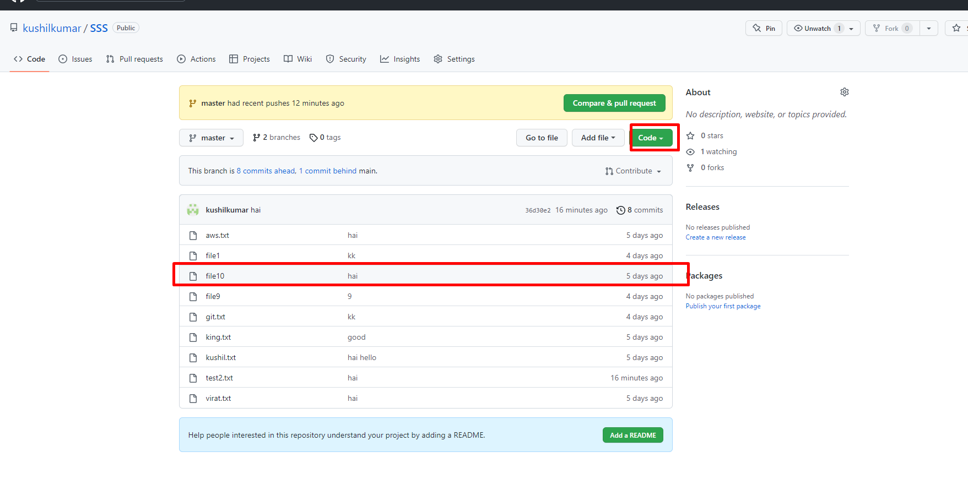

Successfully pulled.

